Modelling Open-Play Crosses in Ecuadorian Football:
A Cross-Validated Framework for Delivery Quality, Defensive Transitions,
and Second-Ball Recovery

Marc Lamberts
Waltzing Analytics
July 2026

Abstract
Crosses are among the most frequent yet least efficient attacking actions in professional football. Across 136 Ecuadorian top-flight matches in the 2026 season (Ecuador 2026), 3,580 open-play crosses were attempted, of which only 21.3% found a teammate and 11.6% led to a shot. We present a six-model machine-learning framework, trained on Opta event data with gradient-boosted trees (XGBoost) and validated with match-grouped 5-fold cross-validation, that models the full lifecycle of an open-play cross: completion probability, chance-creation probability, goal-contribution probability, defensive clearance probability, a continuous delivery-value score, and a four-class outcome classification. A seventh stage, chained onto the defensive-clearance stage, applies an existing, separately trained Ecuador 2026 headed-clearance landing-location model (R² = 0.41 / 0.52 on the x / y landing coordinates, held-out test set) rather than retraining one, enabling a data-driven “second-ball recovery zone” analysis for attacking transition shape. Beyond headline discrimination (AUC 0.73–0.75 across the four binary classifiers — a narrower and uniformly lower band than the equivalent English Premier League models, consistent with the roughly 2.7× smaller sample), we report calibration, feature-importance, and confusion-matrix diagnostics that surface two methodologically important failure modes: probability over-confidence induced by class-imbalance correction, and a rare-class collapse in the four-class outcome classifier that its headline 78.7% accuracy conceals. We discuss the practical implications of both for applied recruitment and coaching use, and outline the data (player-tracking, additional seasons) that would be required to raise the performance ceiling further.
1. Introduction
Open-play crosses are a high-volume, low-conversion attacking pattern: in the dataset analysed here, fewer than one in eight crosses produced a shot, and roughly one in one hundred produced a goal. Despite this inefficiency, crosses remain a structurally important part of the attacking repertoire of most Ecuadorian top-flight teams, and evaluating them well matters for recruitment (which wide players create danger relative to their delivery volume), tactical planning (which zones are worth crossing from and which are not), and defensive coaching (where does a cleared cross actually go, and who should be positioned to win it back).
Public cross models typically collapse this into a single “cross quality” or expected-assist number. We instead decompose the cross into six distinct, purpose-built models that separately answer: will it be retained, will it produce a shot, will it produce a goal, will it be cleared, how dangerous is it in a continuous sense, and which of four discrete outcomes will occur. We additionally chain a seventh stage — an existing headed-clearance landing-location regressor, already trained separately for Ecuador 2026 rather than retrained here — onto the defensive-clearance stage, connecting the attacking event to the defensive transition that follows it. This lets us answer a question the completion/chance/goal models cannot: not just whether a cross gets cleared, but where the loose ball is likely to land afterwards, which is directly actionable for positioning attacking players to win it back.
The contribution of this work is threefold. First, a reproducible feature-engineering and event-extraction methodology for isolating open-play crosses from an Opta-style event feed, with shots linked back to their originating cross via the feed's own relational qualifier — identical to the methodology we previously applied to English Premier League data, letting the two studies be compared directly. Second, a six-model suite covering the full outcome space of a cross, trained and validated with match-grouped cross-validation to prevent leakage, on a materially smaller single-competition sample than the Premier League study (136 matches vs. 380). Third — and the primary methodological contribution, replicated here from that earlier study — a full diagnostic evaluation (calibration curves, per-fold ROC variability, feature importance, confusion matrices, and residual analysis) that goes beyond a single headline metric per model and surfaces two failure modes that would otherwise go unnoticed, testing whether they recur on an independent dataset.
2. Data and Event Definitions
The data source is an Opta/Stats Perform event feed covering 136 matches of the Ecuadorian top flight, 2026 season (Ecuador 2026, 16 teams). Each match file uses the same schema as the English Premier League feed we have previously analysed with this methodology: every event carries a type identifier, pitch coordinates (x, y, normalised 0–100 in each team's own attacking direction), and a set of qualifier flags that encode additional context (body part, phase of play, pass end-location, and so on), which we confirmed directly on a sample of match files before extraction.
A cross was identified as a pass event (typeId 1) carrying qualifierId 2 (“Cross”). To isolate open-play deliveries, we excluded any cross carrying a free-kick-taken (5), corner-taken (6), set-piece (24), from-corner (25), direct-free-kick (26), or throw-in-set-piece (160) qualifier. Shots were linked back to the cross that created them via qualifierId 55 (a relational “related event id” field the feed uses to connect a shot to its assisting pass). A cross was labelled as defended when the immediately following on-ball event was a clearance or interception by the opposing team; it was further labelled a headed clearance when that clearance carried the header qualifier (15) and had usable landing coordinates.
Table 1. Dataset summary.
Metric | Value
Open-play crosses (analysis sample) | 3,580
Matches | 136
Teams | 16
Completion rate | 21.3%
Chance-creation rate | 11.6%
Goal rate | 1.03%
Defended (cleared/intercepted) rate | 47.6%
Headed clearances, all (existing landing-model's training set) | 3,125
Headed clearances originating from a cross (this study) | 757

3. Methods
3.1 Feature Engineering
Each cross was described by fourteen numeric features — start and end coordinates (x, y, end_x, end_y), pass length and angle, minute of the match, distance to goal at the start and end location, byline proximity, delivery depth, lateral shift, end-zone distance from the central channel, and a cutback (“pull-back”) flag — and four categorical features: delivery body part (right foot, left foot, header, other), phase of play (regular vs. fast break), wide channel (left vs. right, by start y-coordinate), and match period. Categorical features were one-hot encoded; numeric features were passed through unscaled, as gradient-boosted trees are invariant to monotonic feature scaling.
One methodological caveat applies to the completion model specifically: the pass end-location qualifiers report where the ball actually ended up, not a hand-labelled intended target. For an incomplete cross this is the interception or out-of-bounds point rather than the crosser's aim point. This is standard practice for event-data pass-outcome models and is not unique to this work, but it means the completion model should be read as a target-zone-conditioned difficulty baseline rather than a pure pre-strike intent model.
3.2 Model Suite
Six models were trained directly on the cross-level feature set described in Section 3.1, sharing a common ColumnTransformer preprocessing pipeline. A seventh model, described separately in Section 3.3 because it is trained on a different event population and a different feature set, is chained onto the output of cross_defended to extend the pipeline from “was the cross defended” to “where did the defensive action send the ball.”
Model | Type | Target | Positive rate
cross_completion | Binary | Cross retained by a teammate | 21.3%
cross_chance_creation | Binary | Cross directly leads to a shot | 11.6%
cross_goal_contribution | Binary | Cross directly leads to a goal | 1.03%
cross_defended | Binary | Defending team clears/intercepts | 47.6%
cross_delivery_value | Regression | Continuous danger value (0–1) | —
cross_outcome_multiclass | 4-class | incomplete / complete / shot / goal | —
clearance_landing (§3.3, reused) | Regression (x, y) | Headed-clearance landing location | —

The continuous delivery-value target was constructed as an exponential decay of the resulting shot's distance to goal (value = e^(−d/12), d in pitch units) when the cross produced a shot, and zero otherwise — a lightweight proxy for shot danger that does not require a separately calibrated shot-xG model. All four binary classifiers and the regressor were XGBoost models (250 estimators, max depth 4, learning rate 0.05, subsample and column-subsample 0.8); the four binary classifiers used scale_pos_weight, set to the training-fold negative-to-positive ratio, to correct for class imbalance. The four-class outcome model used the same XGBoost configuration without positive-class reweighting.
3.3 Chained Clearance-Landing Model (Reused, Not Retrained)
The cross_defended model (Section 3.2) answers whether a cross is cleared, but not where the loose ball subsequently goes — a question that matters for attacking transition shape and is answerable only by modelling the clearance event itself, not the cross that preceded it. Unlike the equivalent Premier League study, where we trained this seventh stage from scratch, Ecuador 2026 already has a separately built, separately maintained headed-clearance landing model, trained on every headed clearance in the same 136 match files (not only those following a cross), extracted the same way (typeId 12 with the header qualifier, qualifierId 140/141 giving the realised landing x/y): 3,125 events, split 2,485 train / 640 test by a match-grouped 80/20 GroupShuffleSplit. We reuse that model as-is here rather than retraining it, to avoid maintaining two divergent versions of the same artefact and to test whether a model built for one purpose transfers cleanly to a second, cross-specific use case.
That model uses its own feature set, distinct from the cross-level features in Section 3.1, because its unit of analysis is the clearance event rather than the cross: match period and elapsed seconds; the clearance's own start x/y and the corresponding pitch-third/pitch-channel zone; distance from the clearing team's own goal and from the central channel; the clearing team and player identity; and the clearance's qualifier-reported direction. Categorical features (team, player, zone, direction) were one-hot encoded with a minimum-frequency threshold of 5; numeric features were standardised. It is a MultiOutputRegressor wrapping a GradientBoostingRegressor (220 estimators, learning rate 0.04, max depth 3, min_samples_leaf 8) jointly predicting landing_x and landing_y, evaluated against a baseline that predicts the training-set median landing x/y for every test event — identical hyperparameters and evaluation protocol to the model we trained from scratch for the Premier League study, which lets the two results be compared directly (Section 4.6).
We load the existing fitted pipeline and apply it to the 757 crosses in the primary dataset that were cleared specifically by a header, using each clearance's own start location and context as input, to give every such cross a predicted — alongside the observed — clearance landing zone. This is what makes the stage “chained”: the model was fit independently, for a different purpose, on the full clearance population; we connect it to the cross-level dataset only at inference time, not at training time.
3.4 Validation Protocol
All cross-validated metrics use GroupKFold (five folds) grouped by match, so that no match's events appear in both the training and evaluation fold — a standard precaution against leakage in event-stream data, where events within a match are not independent. For each binary and multiclass model we retained the out-of-fold (OOF) predictions to build ROC curves, calibration curves, and the confusion matrix from genuinely held-out predictions rather than the optimistic in-sample scores a model produces on data it was fit on. Fold-level metrics (not only their mean) were retained throughout, enabling explicit reporting of cross-validation variance rather than a single point estimate. A final version of each model was then refit on the full dataset for deployment scoring (the player and team leaderboards use these full-fit predictions); all diagnostic figures in Section 4 use only the OOF predictions.

4. Results
4.1 Discriminative Performance
Table 2 reports cross-validated discrimination for all six models. The four binary classifiers achieved AUC between 0.73 and 0.75 — a narrower band than, and uniformly below, the Premier League study's 0.70–0.80 range once the outlying goal-contribution model is set aside, though the two ranges overlap substantially and the sample here (3,580 crosses, 136 matches) is roughly 2.7× smaller. The delivery-value regression achieved R² = 0.081 (MAE = 0.071); the four-class outcome model achieved 78.7% accuracy but only 0.312 macro-F1 — a gap returned to in Section 4.4.
Table 2. Cross-validated performance (mean ± SD across 5 folds).
Model | Metric | Mean ± SD
Completion | AUC | 0.754 ± 0.015
Chance creation | AUC | 0.741 ± 0.019
Goal contribution | AUC | 0.732 ± 0.051
Defended / cleared | AUC | 0.748 ± 0.019
Delivery value | R² | 0.081 ± 0.032
Delivery value | MAE | 0.071 ± 0.001
Outcome (4-class) | Accuracy | 0.787 ± 0.006
Outcome (4-class) | Macro F1 | 0.312 ± 0.026

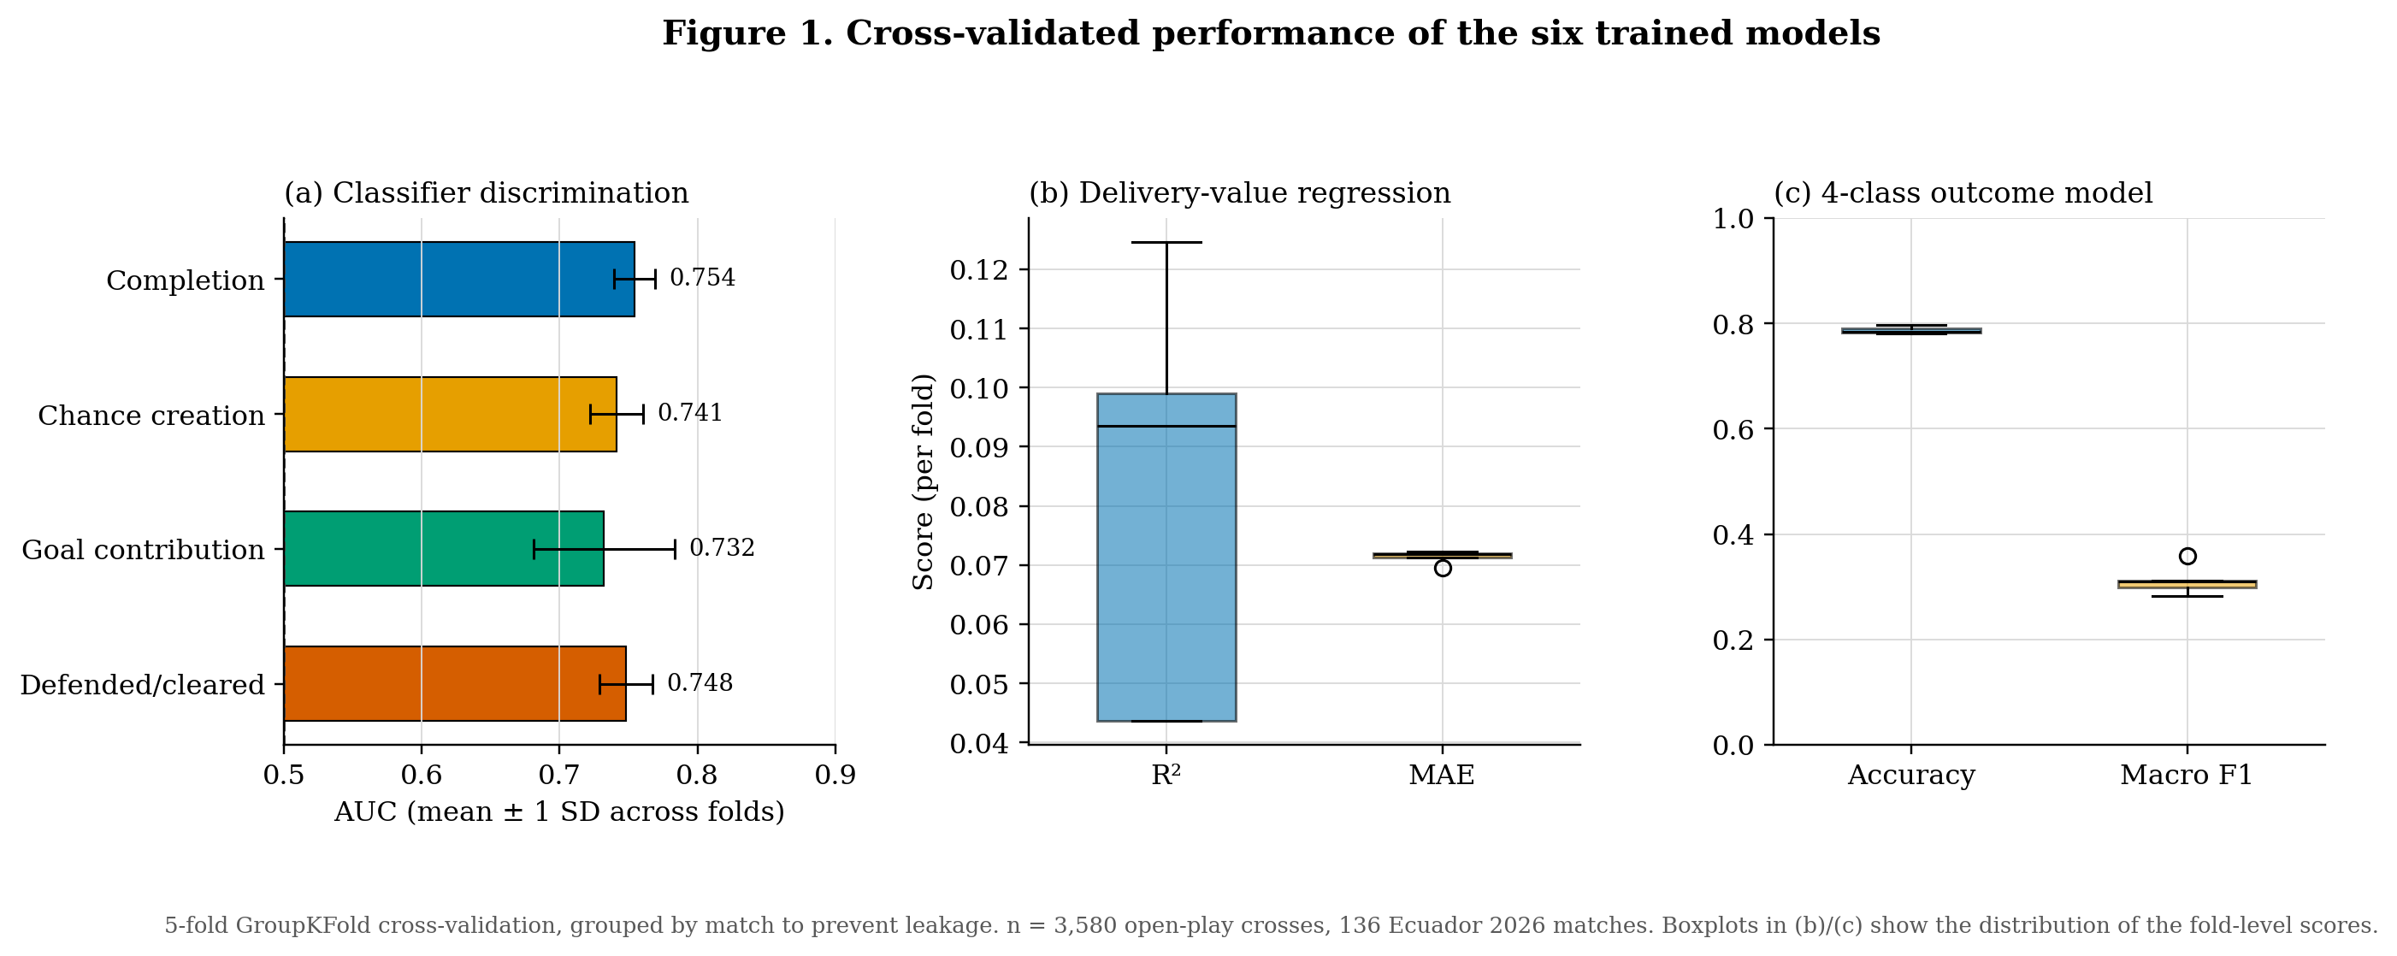
Figure 1. Cross-validated performance of the six trained models. Error bars and boxplots show the distribution of fold-level scores rather than a single point estimate.
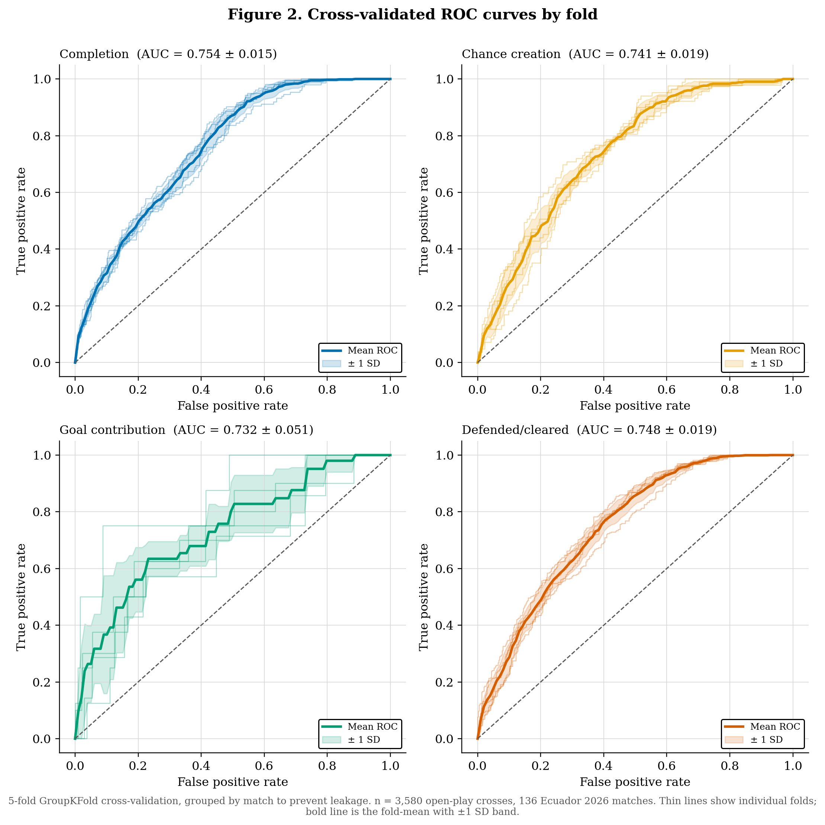
Figure 2. Per-fold ROC curves (thin lines) with fold-mean and ±1 SD band (bold line, shaded region) for the four binary classifiers. The goal-contribution model's AUC varies more than twice as much across folds (±0.051) as the other three (±0.015–0.019), consistent with its far smaller positive class (1.03% base rate, only 37 goal events total) making individual folds noisier estimates of the same underlying discrimination — the same pattern, more pronounced, that we observed for the equivalent Premier League model (±0.037 on a 4.8× larger positive class).
4.2 Calibration
Discrimination (AUC) measures whether a model ranks positives above negatives; it says nothing about whether the predicted probabilities themselves are trustworthy. Figure 3 shows reliability diagrams for all four binary classifiers built from out-of-fold predictions. As in the Premier League study, the defended/cleared model — whose classes are close to balanced (47.6% positive) — sits closest to the diagonal, while the completion and chance-creation models are visibly over-confident: crosses the completion model assigns ≈80% probability of success are observed to succeed only around 50% of the time here (versus ≈60% in the Premier League data). This is a direct, known side effect of scale_pos_weight: reweighting the minority class during training improves rank ordering (and therefore AUC) but systematically inflates predicted probabilities for the reweighted class. That this same distortion reproduces on an independent competition, dataset, and season is evidence it is a property of the training procedure rather than an artefact of one dataset. Practically, the raw probability outputs of these two models should not be interpreted as calibrated frequencies without a post-hoc recalibration step (Platt scaling or isotonic regression); they remain valid for ranking and relative comparison, which is how they are used in the player and team leaderboards in Section 4.7.
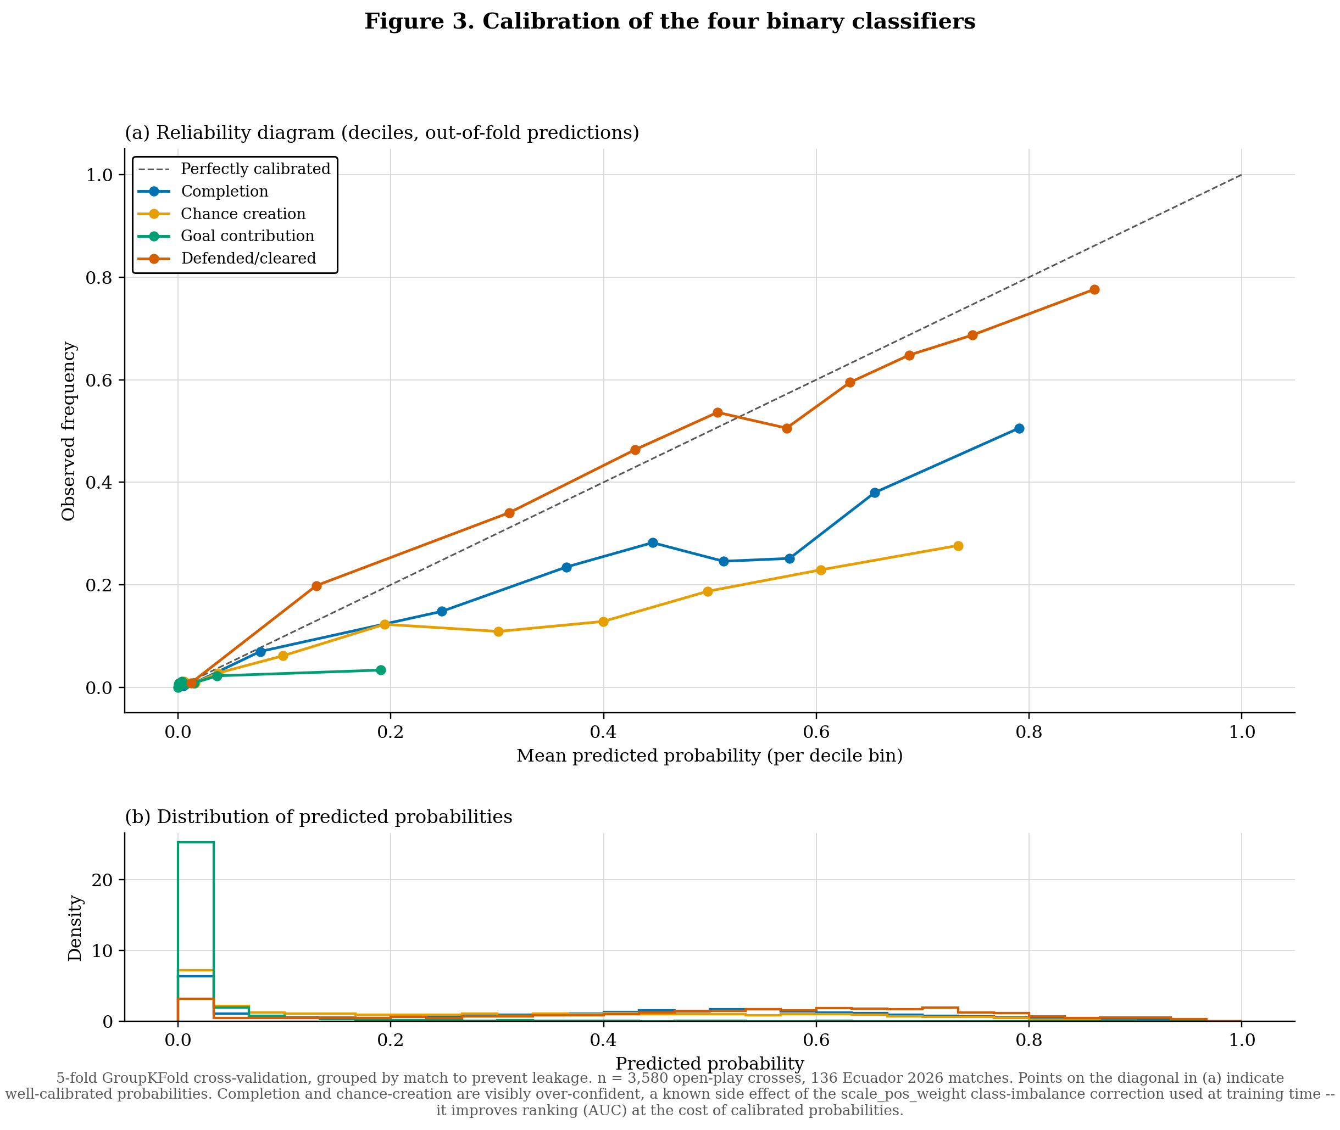
Figure 3. (a) Reliability diagrams (decile bins, out-of-fold predictions) for the four binary classifiers; points on the diagonal indicate calibrated probabilities. (b) Distribution of predicted probabilities per model.
4.3 Feature Importance
Figure 4 reports the top-eight gain-based feature importances for each of the six models. As in the Premier League study, pass length and lateral shift dominate the completion and defended models, and end-zone distance from the central channel dominates the chance-creation and goal-contribution models — the same well-established pattern that centrally delivered crosses are disproportionately dangerous, again reproducing across an independent dataset. One genuine difference: the delivery-value regression here is driven primarily by which wide channel the cross was delivered from (wide_channel_right) and delivery body part, rather than by distance-to-goal-at-end as in the Premier League model — plausibly a smaller-sample artefact given the regression's already-wide fold variance (Table 2), rather than a genuine tactical difference between competitions.
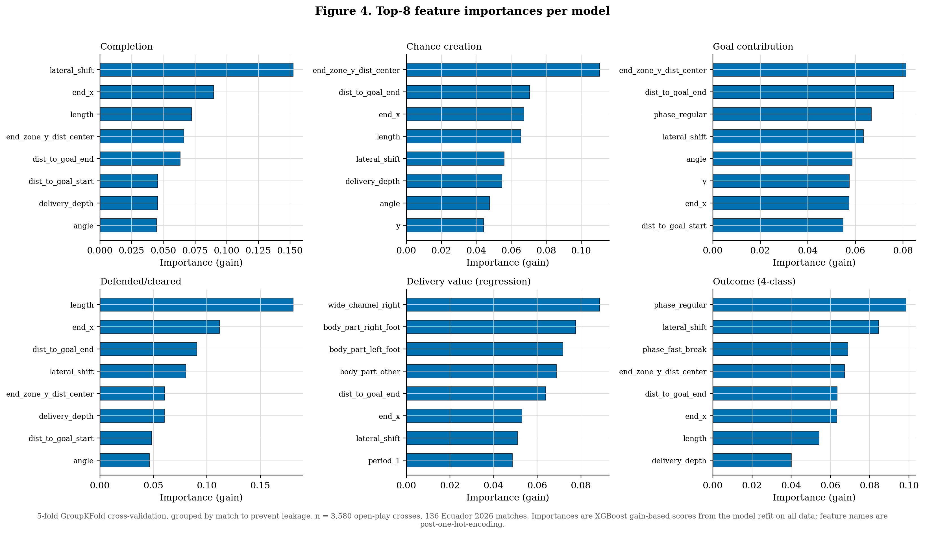
Figure 4. Top-8 XGBoost gain-based feature importances per model, from the model refit on all data.
4.4 The Outcome Model's Class-Imbalance Failure
The four-class outcome model reports 78.7% accuracy, which reads as a strong result in isolation. The out-of-fold confusion matrix (Figure 5) shows why that number is misleading: of the 37 true goal events, the model predicts “incomplete” for 91.9% of them, “shot_no_goal” for 5.4%, and correctly predicts “goal” for only 2.7% (one event) — a marginally less total a failure than the Premier League model's 0% recall on goals, but not a usable recall rate either way. Of the 379 true shot_no_goal events, 96.6% are predicted “incomplete” and only 1.3% are correctly predicted. The intermediate complete_no_shot class is correctly recovered only 21.5% of the time here — worse than the 40.6% recovered in the Premier League data — with 78.2% misclassified as “incomplete.” The headline accuracy is driven almost entirely by the majority incomplete class (2,797 of 3,580 crosses, 78.1% of the sample), which the model predicts correctly 97.7% of the time. Macro F1 (0.312, unweighted across the four classes) is the metric that actually reflects this and was reported alongside accuracy throughout; it is the number that should be used to judge this model, not accuracy in isolation.
The practical implication is the same as in the Premier League study: the four-class model should not be used to identify which crosses will produce a shot or a goal — that is what the dedicated cross_chance_creation and cross_goal_contribution binary specialists are for. The multiclass model's residual value is coarse-grained: distinguishing complete from incomplete deliveries, and even that distinction is noticeably weaker here than in the larger Premier League sample. We retain it in the released model suite for that narrower purpose and flag the shot/goal-class collapse explicitly rather than omit it.
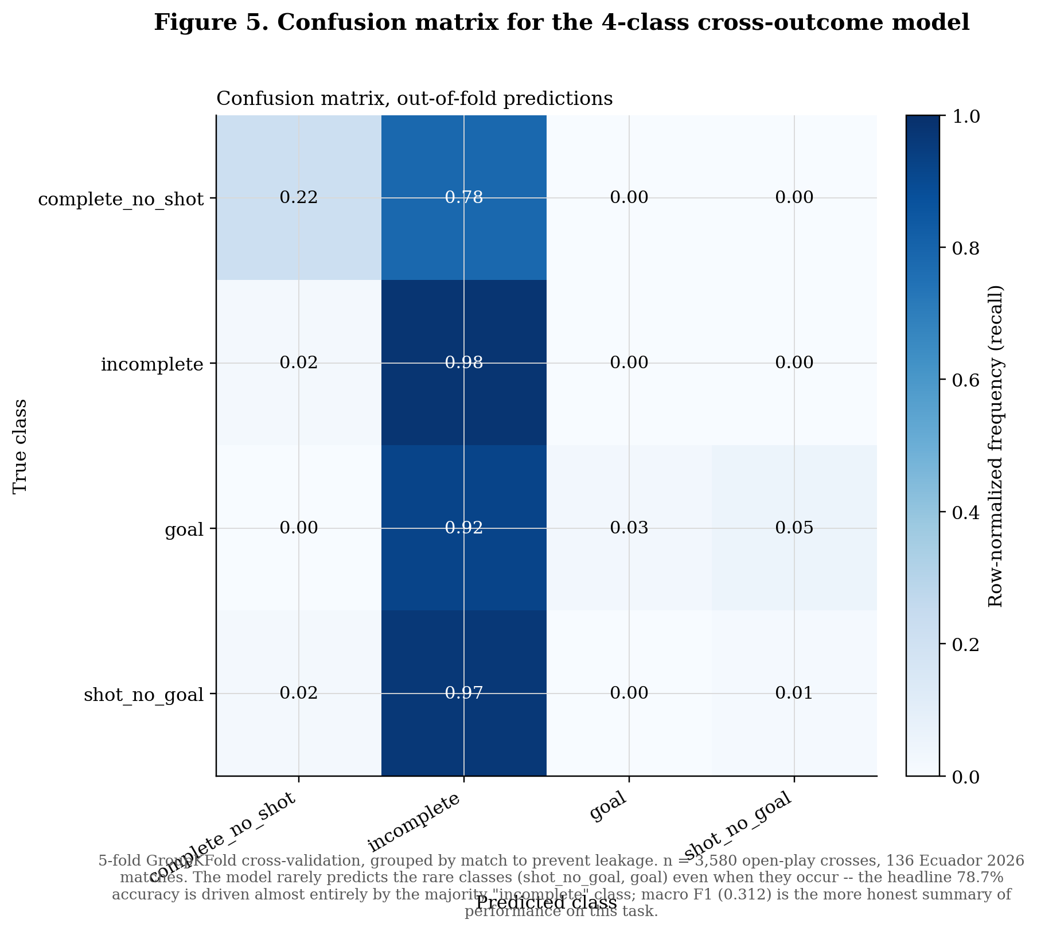
Figure 5. Row-normalised (recall) confusion matrix for the 4-class outcome model, out-of-fold predictions. The model collapses almost entirely onto the majority “incomplete” class for the two rarer classes (shot_no_goal, goal).
4.5 Regression Residuals
Figure 6 shows out-of-fold predicted-vs-actual and residual diagnostics for the delivery-value regression. The residual distribution has a sharp mode near zero (the 88.4% of crosses for which the true value is exactly zero, i.e. no shot resulted) and a secondary, smaller mode of positive residuals around +0.2 to +0.4 — crosses that did produce a high-value chance but for which the model under-predicted. This pattern is the expected behaviour of a regressor trained on a mostly-zero target: the model is conservative and shrinks its predictions toward zero, which minimises average error but systematically under-states the value of the crosses that matter most. This is consistent with, and explains, the modest R² (0.081) reported in Section 4.1, and reproduces the same pattern — down to the location of the secondary mode — that we observed in the larger Premier League sample.
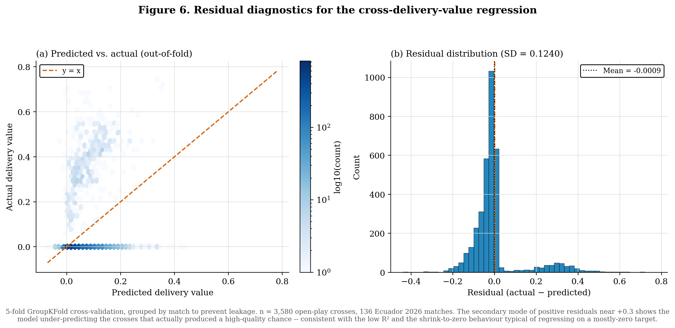
Figure 6. (a) Predicted vs. actual delivery value (hexbin density, log-scaled), out-of-fold. (b) Residual distribution, showing the secondary positive-residual mode corresponding to under-predicted high-value crosses.
4.6 Chained Clearance-Landing Model
The existing, reused Ecuador 2026 headed-clearance landing model (Section 3.3) achieves R² = 0.408 (x) and 0.518 (y) on its held-out, match-grouped test set of 640 clearances (Table 3), with a mean landing-location error of 17.7 pitch units (median 15.6) — substantially better than a median-prediction baseline (mean error 25.8 units, median 23.8), though clearly less accurate than the equivalent model we trained from scratch for the Premier League study on a roughly 3.5× larger clearance population (11,068 events; mean error 15.5 units). Because both models share identical hyperparameters and evaluation protocol (Section 3.3), this gap is attributable to training-set size rather than to a methodological difference — direct evidence that this class of spatial model benefits from more data in the same way the cross-level classifiers in Section 4.1 do.
Table 3. Clearance-landing model performance, held-out test set (n = 640; existing pretrained model).
Metric | Model | Baseline (train median)
R² (landing_x) | 0.408 | −0.027
R² (landing_y) | 0.518 | −0.004
MAE (landing_x) | 7.59 | 9.82
MAE (landing_y) | 14.42 | 22.04
Mean landing error (pitch units) | 17.69 | 25.76
Median landing error (pitch units) | 15.59 | 23.78
Within 10 pitch units | 27.2% | 13.9%
Within 15 pitch units | 47.7% | 26.7%

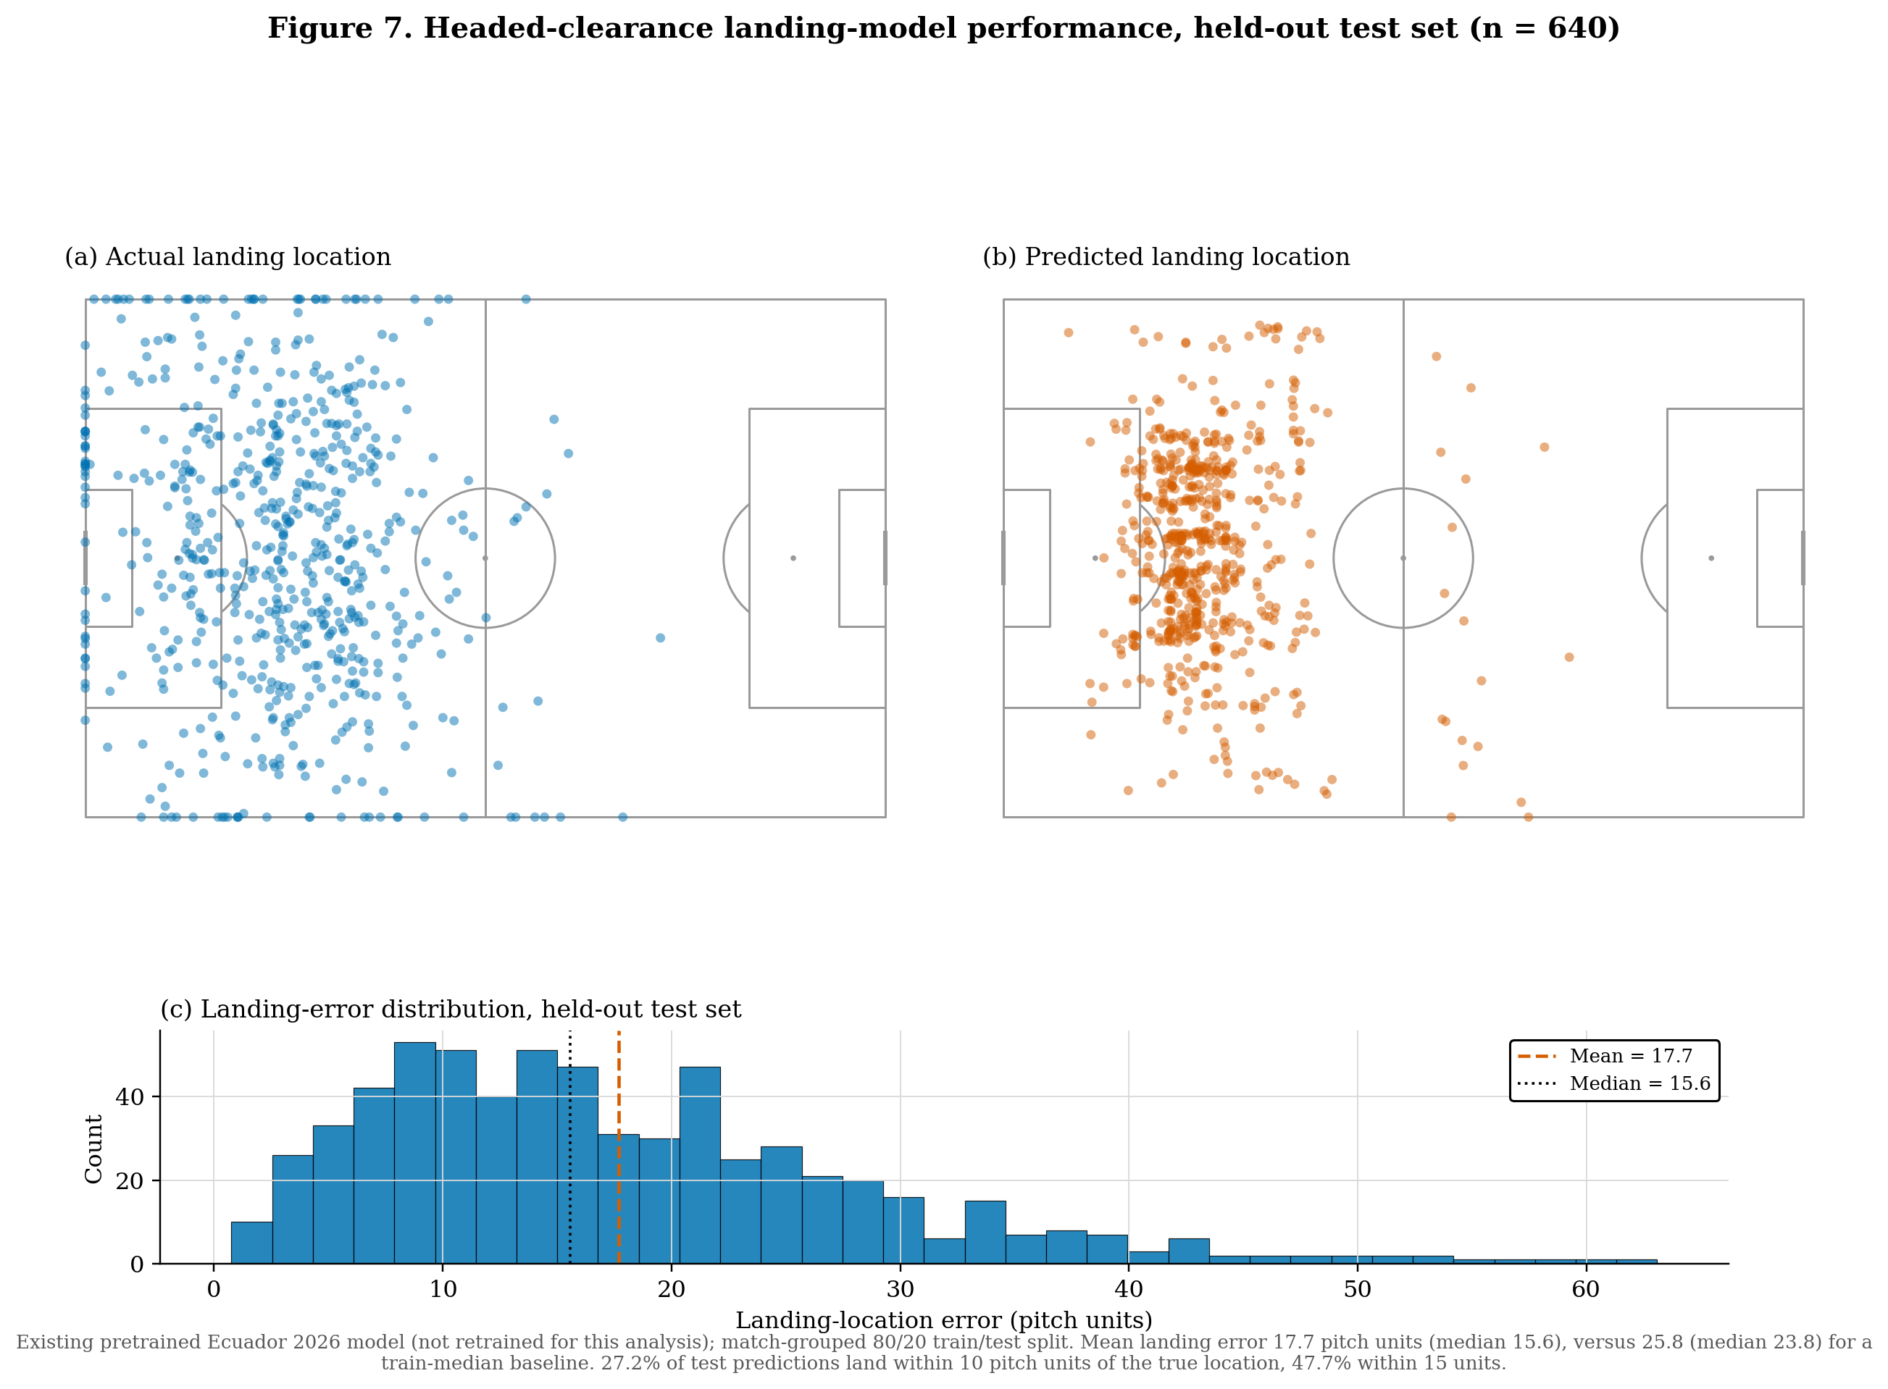
Figure 7. Headed-clearance landing-model performance, held-out test set (n = 640). (a) Actual landing locations. (b) Predicted landing locations — visibly more concentrated than (a), the same shrink-to-mean pattern documented for the delivery-value regression in Figure 6. (c) Distribution of per-clearance landing error.
Figure 7(a)/(b) shows the same qualitative pattern as the Premier League model despite the lower R²: actual landing locations (a) spread across the full width of the pitch and into the middle and attacking thirds, while the model's predictions (b) cluster more tightly around the central channel of the defensive and middle thirds. As in the Premier League data, the model is more confident about how far a clearance travels down the pitch (x-axis, R² = 0.408) than about which channel it lands in across the pitch's width — except here the y-axis R² (0.518) is actually the higher of the two, the reverse of the Premier League result (R² = 0.641 x / 0.626 y), a difference we would attribute to the much smaller sample rather than to a real competition-level effect without further data.
Applied to the 757 crosses cleared specifically by a header, the reused model lets us identify, per team, the zones a second ball is most likely to land in after their own crosses are defended — directly informing where to station players in a rest-attack shape to win possession back. CSD Independiente del Valle clear crosses furthest beyond model expectation among defending teams (+13.7 pitch units versus their attackers' average expected clearance distance), ahead of CSD Macará (+13.4) and Barcelona SC (+13.3).
4.7 Applied Outputs
The full model suite additionally produces player- and team-level leaderboards. By season-total “cross threat” (the sum of the delivery-value model's predictions across all of a player's crosses), J. Ayoví (Guayaquil City FC) ranks first (4.32) on an above-average 38.8% completion rate — unlike the Premier League leaderboard, where the top-ranked crosser (Pedro Neto) combined high threat with a below-average completion rate, illustrating that the two are not always in tension and that the separation of delivery danger from raw completion still adds information even when a player is doing reasonably well on both. At team level, CSD Independiente del Valle lead attacking cross threat (17.5) while Delfín SC lead defensive clearance value added (+7.5 clearances above expectation across the season); Guayaquil City FC, whose crossing led the attacking table, rank last on defensive clearance value added (−15.6), a reminder that the two leaderboards measure unrelated capabilities and a team's attacking cross output says nothing about how well it defends crosses against it.
5. Discussion
Four findings carry direct practical weight. First, ranking and calibration are not the same thing, and models trained with imbalance correction should be labelled accordingly: the completion and chance-creation models are reliable for ranking players and crosses against each other but should not be read as literal probabilities without recalibration. Second, headline accuracy is an unreliable summary statistic for imbalanced multiclass problems in this domain — the outcome model's 78.7% accuracy would, read alone, suggest a usable shot/goal-outcome classifier; the confusion matrix shows it is not one, and only the paired macro-F1 and confusion-matrix diagnostics reveal that. We would recommend this pairing as standard practice for any multiclass sports-event outcome model, not only this one. Third, chaining a defensive-transition model (clearance landing) onto an attacking-event model (cross outcome) produces a genuinely new class of actionable output — second-ball recovery positioning — that neither model produces alone, suggesting further value in chaining models across the attack/transition boundary more broadly (e.g. shot → rebound location, or turnover → counter-press recovery zone). Fourth, and specific to this study: applying this methodology to a second, independent competition reproduced both the calibration over-confidence and the multiclass rare-class collapse found in the Premier League study, on a dataset roughly 2.7× smaller, a different competition, and a model that was reused rather than retrained for the clearance stage. Findings that survive that many changes at once are unlikely to be dataset-specific artefacts.
The feature-importance results (Section 4.3) are also worth reading against the completion-model caveat noted in Section 3.1: because pass end-location is derived from where the ball actually ended up rather than a hand-labelled target, and end-location features dominate every model's importance ranking, some of each model's apparent skill may reflect outcome-adjacent information rather than pre-strike difficulty alone. This is a standard limitation of event-data models built without freeze-frame or tracking data, and applies to essentially all public pass- and cross-quality models built on event feeds; it does not invalidate the ranking use case but should temper any claim that these models measure decision quality at the moment of delivery in a strict, pre-outcome sense.
6. Limitations and Future Work
- No player-tracking or freeze-frame data. Defender and goalkeeper positions at the moment of delivery are the single largest missing input relative to public tracking-data cross models; incorporating them is the most likely route to raising the AUC ceiling above the 0.73–0.75 range achieved here.
- Sample size. At 136 matches and 3,580 open-play crosses, this dataset is roughly 2.7× smaller than the Premier League study's, and every fold-level standard deviation in Table 2 is correspondingly wider; the AUC estimates themselves (Table 2, Figure 2) are consequently less precise, even where the point estimates are similar. Pooling additional Ecuadorian seasons would tighten these estimates without changing the modelling approach.
- Probability recalibration. Isotonic or Platt-scaling post-processing on the completion and chance-creation models would directly address the over-confidence documented in Section 4.2, at the cost of an additional held-out calibration split.
- Rare-event variance. The goal-contribution model's fold-level AUC standard deviation (±0.051, more than double the other binary models) reflects the inherent difficulty of estimating discrimination for a 1.03%-positive-rate target (37 goal events total) from a single, comparatively small season; a multi-season pool would tighten these estimates without changing the underlying modelling approach.
- Outcome-model rare-class recall. A cost-sensitive loss, hierarchical two-stage classifier (complete/incomplete, then shot-outcome conditional on completion), or SMOTE-style resampling are natural next steps for recovering usable recall on the shot_no_goal and goal classes documented in Section 4.4, rather than relying on the separate binary specialists as a workaround.
- Reused, not re-optimised, clearance model. The clearance-landing stage (Section 3.3) was built for Ecuador 2026's own analytics work, not specifically to serve this cross pipeline; its feature set, hyperparameters, and train/test split were fixed independently of this study. Retraining it specifically on cross-originated clearances (rather than applying a model trained on the full clearance population) might improve accuracy on that subset, at the cost of the larger, more stable training sample the current approach benefits from.
- Scope. The same extraction and modelling methodology could be extended to corner and free-kick crosses for a like-for-like open-play-versus-set-piece delivery comparison, and to the wider clearance population (not only headers) for the transition-positioning analysis in Section 4.6.
7. Conclusion
A six-model, cross-validated framework decomposing the open-play cross into completion, chance-creation, goal-contribution, defended, delivery-value, and outcome components — chained to a seventh, reused stage predicting headed-clearance landing location — provides both applied outputs (player and team leaderboards, second-ball recovery zones) and, through explicit calibration, feature-importance, confusion-matrix, and residual diagnostics, an honest account of where each model can and cannot be trusted. Applying the identical methodology to Ecuador 2026, a smaller and independent dataset from the Premier League study this pipeline was first built on, reproduced both of that study's clearest findings — imbalance-correction-induced probability over-confidence, and a rare-class collapse hidden behind a plausible-looking accuracy figure — suggesting they are properties of the modelling approach rather than artefacts of one league or season, and are offered as a general caution for applied sports-analytics modelling more broadly: a single headline metric is rarely sufficient to certify a model fit for use.
References
Chen, T. and Guestrin, C. (2016). XGBoost: A Scalable Tree Boosting System. Proceedings of the 22nd ACM SIGKDD International Conference on Knowledge Discovery and Data Mining, 785–794.
Okabe, M. and Ito, K. (2008). Color Universal Design (CUD): How to Make Figures and Presentations that are Friendly to Colorblind People. J*FLY Data Depository.
Opta / Stats Perform. Event-level match data, Ecuador 2026 season, and English Premier League, 2025–26 season.
Pedregosa, F. et al. (2011). Scikit-learn: Machine Learning in Python. Journal of Machine Learning Research, 12, 2825–2830.
Lamberts, M. (2026). Modelling Open-Play Crosses in the Premier League: A Cross-Validated Framework for Delivery Quality, Defensive Transitions, and Second-Ball Recovery. Waltzing Analytics internal report (companion study, same methodology).

